Most Prolific Era in Boone High Sports
By Bob Sapp
January 2022

I feel extremely lucky to have grown up in Boone when I did. I have always believed that I witnessed the greatest era of Boone High athletics. As my 50-year class reunion came upon me this past year, I started questioning that feeling …. was it just me being nostalgic or was this truly the greatest era in Boone High annals? So, I made several visits to the Ericson Public Library in Boone wading through years of the Boone News Republican on microfilm. The memories came alive, and I am convinced, more than ever, that this was the golden era for Boone High athletics. I looked closely at the decade starting with the 1962-63 school year and ending with 1971-72.
Before I provide more detail on these achievements, I need to give you some context. The Boone boys’ teams competed in the Central Iowa Conference. Through 1968, the CIC was composed of Boone, Ames, Marshalltown, Newton, Grinnell, and Oskaloosa. A new alignment was formed starting with the 1968-69 school year. In addition to Boone and Grinnell, the new CIC included Ankeny, Urbandale, Southeast Polk, Saydel and South Tama. Indianola was added in 1970-71. The girls were not a part of any conference. In fact, the girls had a limited number of activities available to them. They had basketball, synchronized swimming, golf, tennis, cheerleading, band, and orchestra….no softball, no volleyball, no swimming, no track. Boone was the 40th largest school district in 1962 (out of 442) and dropped to 45th by 1972. The average class size during that decade was 200. Today, Boone is the 61st largest school, out of 453, in Iowa averaging 160 students per class.

Classifications set by the Iowa High School Athletic Association were different from today. There were no football playoffs. Baseball had only one class. Schools of all sizes competed against each other for the state title. Only two teams qualified for the state baseball tournament through 1966. In 1967 and 1968, four teams qualified for state. That was expanded to 8 teams from 1969 through 1972. In other words, the 1965 team had to win 8 straight games to get to state, the 1967 team 7 straight and the 1970-72 teams 6 straight. Boys’ basketball had only one class until 1967 when it added a second class for smaller schools. Golf and track had two classes for the entire decade. Girls’ basketball was 6-on-6 and competed with only one class.

Please allow me to summarize the major achievements by year:
1963: The boys’ basketball team qualified for the state tournament… Historically, the Boone boys’ basketball team has made it to the state tournament 9 times. But 7 of those events occurred between 1919 and 1931. The 1962-63 team was the last squad to qualify. Jim Ranglos was the young head coach of the Toreadors. Coach Ranglos had played for the University of Colorado. When he was a junior (1954-55), the team made it to the Final Four. They were beaten by San Francisco who was led by Bill Russell and KC Jones. However, they beat Iowa (led by Carl Cain) in the consolation game and finished 3rd. Coach Ranglos played well enough to make the all-tournament team along with Russell and Jones. After college, he played with the Phillips Oilers (66ers). They were the top amateur team in the nation during those years…..the NBA was in its infancy at that time. But back to the 1963 Toreadors…..the team was led by Roger Dutton, Mike Loehrer, and Dick Musser. Boone ended the regular season with a 10-6 record, 6-4 in the tough CIC. They then reeled off 5 wins in tournament play beating previously undefeated Carroll 76-71 to qualify for state. Boone faced Storm Lake in the first round of the tourney. Leading scorer, Roger Dutton, was saddled with 4 fouls in the first half. He had to play cautiously after that, but the Toreadors still led by 5 with 3 minutes left. However, they missed 4 free throws in the waning minutes and Storm Lake won 48-47. Roger Dutton was named to the first team all-state.
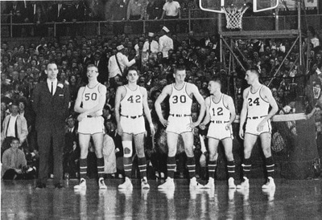
1963 starting lineup (L to R): Coach Jim Ranglos, Dick Musser, Mike Loehrer, Mike Bennett , Marv Nicholson, Roger Dutton
Girls Basketball: For the second year in a row, Jackie Parrish was named to the first team all-state as a guard.
Baseball: Boone finished with an overall record of 15-8. It was second to Oskaloosa in the CIC with a record of 8-2. The Toreadors were beaten in the finals of the district by West Des Moines Valley (7-0). Sophomore Jack Mustapha finished 10-0 with 131 Ks in 82 2/3 Innings pitched.
Football: With Brett Downey at quarterback and Jude Rolfes leading the CIC in rushing, the Toreadors were 6-1 and ranked 11th in the state. Rolfes was 1st team All-CIC along with Dick Musser (end), John Hendricks (tackle) and Toby Anderson (guard). Hendricks was named 1st team all-state, and Anderson was 3rd team all-state. The defense only allowed 12 points in the last 5 games.

1964: Girls’ Basketball: Terri Carlson averaged 30.4 points as a junior (1963-64). She would average 27.8 points the next year as a senior.
Baseball: Boone improved to 18-5 overall finishing 2nd in the CIC with an 8-2 record. They won the Sectional and District tournaments before getting beat by Dowling in the Sub-state. Jack Mustapha led the way as a Junior. He had a 12-2 pitching record. He pitched 97 innings giving up 20 earned runs (1.44 ERA) on 46 hits with 174 strikeouts. He also hit .338 for the season.
Football: The football team ended the season 8-0 and ranked #1 in the state by the UPI and #3 by the AP. After squeaking by a good Fort Dodge team (14-12) in the opener, the 1964 Boone squad outscored its opponents 245 to 41 in the next seven games. Merle Harris was named the state’s Coach of the Year by the Des Moines Register. The team was led by a powerful rushing attack. Playing a “T” formation, Marty Rinehart and Ted Hora were the halfbacks with Don Riker as the fullback. The three backs finished first (Rinehart), second (Hora) and third (Riker) in the CIC in rushing. In a highlight game, Rinehart rushed for 220 yards against Ames. In typical Coach Harris fashion, Merle’s comment in the paper regarding that game was that he was disappointed with his downfield blocking. On a side note, Rinehart and Riker did not start the Fort Dodge game because Coach Harris felt they had been giving less than their full effort in practice. First team All-CIC honors were given to Steve Bancroft (Guard), John Newland (End), Marty Rinehart (Running Back), Sid Ericson (Tackle), and Don Riker (Fullback). Sid Ericson was named to the first team all-state (AP) and Don Riker to the 4th team all-state (AP).

1965: Baseball: The Toreadors win the state championship: 1965 was a promising year with ace Jack Mustapha returning as a senior. However, Jack fell ill with hepatitis early in the season (he was out by the third game). Jack lost about 25 pounds during his sickness. He missed the next 8 games and was not strong enough to pitch until 5 more games had passed. At that time, Boone was 9-5 with 3 of the losses in the conference. The team ended the regular season at 12-6 but Mustapha was now healthy. Boone then reeled off 9 straight wins to take the State title. With a favorable schedule, Mustapha was able to pitch the last 3 games. All were no-hitters beating North Tama (Traer) 1-0, Shenandoah 6-0 and Burlington 2-0. An earlier rain-out created a make-up game with Ames to determine the CIC champion in the week following the state championship game. Boone won 9-3 in front of 1,100 fans at Memorial Park. They ended the season 22-6, in a first-place tie with Newton for the CIC crown.
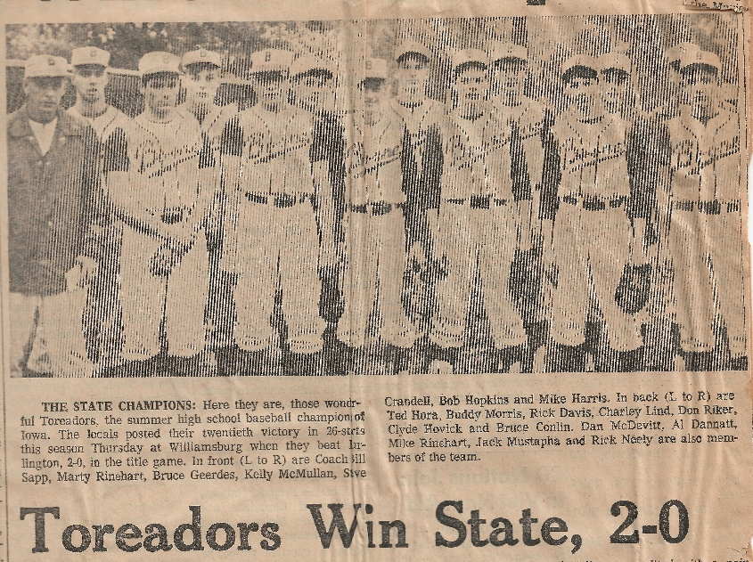

Football: Even though they lost some key players to graduation, the 1965 football team put together a solid season. After winning their first two games, they were ranked third in the state. But a loss to a good Marshalltown team in week four dropped them from the top 10. They ended the season 5-1-2…. the two ties were to Nevada and Ames. They finished second in the conference to Marshalltown. The Toreadors were led by quarterback Mike Harris who was named First Team All-State. Kelly McMullan and Bruce Richeson were the halfbacks who provided a solid running attack. Harris and Steve Bennett (Tackle) were named 1st team all-CIC.

1966: Track and Field: Clyde Hovick became the first track athlete in Iowa history to clear 14’ in the pole vault. He had a season-long battle with Phil Wertmann of Villisca to see who the best vaulter in the state was. A few days after Clyde cleared 14’3/4”, Wertmann made 14’ 1 ½” to claim the state record. However, they both won state titles as they competed in two different classes.
Baseball: Coming off the state championship, the 1966 team nearly repeated. Even though Jack Mustapha had graduated, Bob Hopkins, Steve Crandell and Clyde Hovick filled in nicely on the mound. The starting line-up included Mike Harris at 2nd, Kelly McMullan at ss, Steve Crandell at 3rd, Topper Lyness at 1st, Tom Peterson, Clyde Hovick and Rick Neely in the outfield with Rick Davis behind the plate. After losing their first game to Grinnell, Boone ran off 13 straight victories before losing to a good West Des Moines Valley squad. They went on to win their sectional tournament before bowing again to Valley (9-6) in the district finals. In that game, Crandell re-injured his back and was unavailable to play (and pitch when Hopkins got in trouble). The team ended the season 19-3 winning the CIC title with a 9-1 record. Hopkins was 10-1 on the mound. Harris led the team in hitting with a .447 average followed by Crandell at .420 and McMullan at .333.

1967: Baseball: Another state championship…..Was this team even better than the 1965 team? The team finished 28-1 (only loss was to Newton 1-0 in the last regular game of the season). As there was still only one class, they had to win 9 games to take the state championship. They squeaked by an excellent East Greene team (coached by former Toreador Mel Murken) 1-0 in the Sectional finals. In District play, they beat Ames 3-2, then Panora-Linden 9-0 and previously undefeated Indianola 4-3. Joe Blake was the losing pitcher for Indianola even though he struck out 14 Boone hitters. Boone scored their 4 runs on just 4 hits. The Toreadors then beat Marshalltown 2-0 to get into the state. That year, the state tourney was held in Boone and included four teams…. the stands were packed. In the semi-final, Boone beat perennial power Council Bluffs Thomas Jefferson 6-5 in 9 innings. Topper Lyness supplied the winning runs with a two-run home run in the top of the ninth. It took 10 innings to beat Mason City Newman in the state final, 4-3. Dick Sapp was the winning pitcher. Dick was limited by rule to pitch only 9 innings. Boone took the lead in the top of the 10th and Tom Peterson came on in relief to get the save. Look at the pitching stats for this year….amazing!
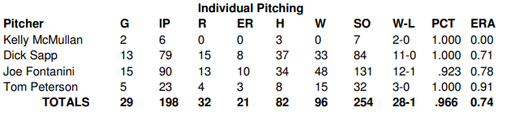
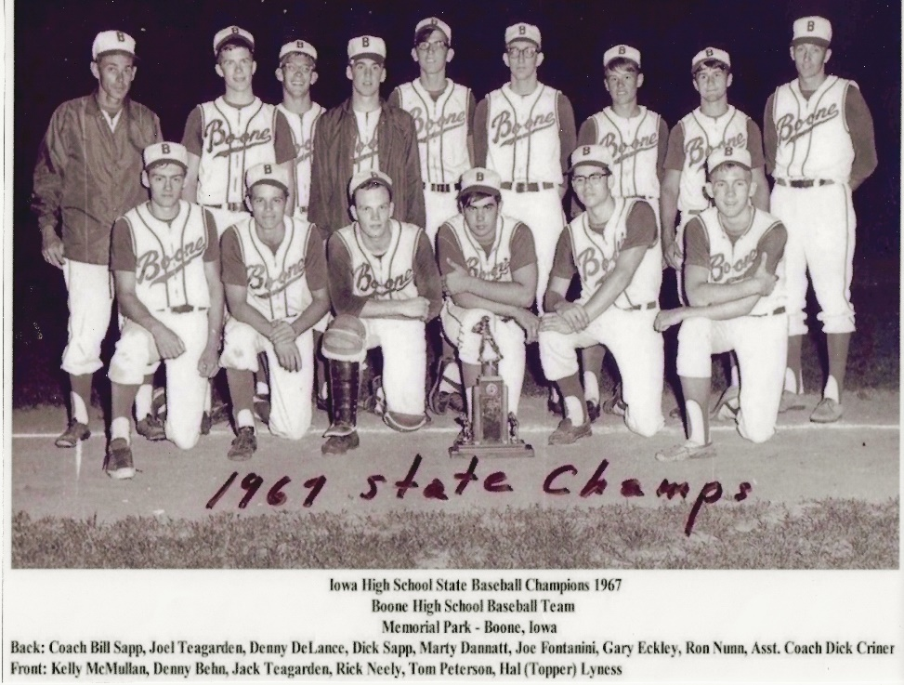

1968: Boys’ Golf: Much of Boone High’s golf success dates to the 1930’s and 1940’s. Led by Ed and Charles Updegraff, Bill Hall, Bill Modeland and Moose Anderson, the golf team was a fixture in the state tournament from 1936 through 1946. In fact, all but Bill Hall, were individual champions during that stretch (Hall was the runner-up in 1936). As a team, Boone tied Roosevelt for the state title in 1946. In the 1960’s, now Dr. Charles Updegraff returned to Boone. He and his wife Amy led the Junior Golf program at Boone Golf and Country Club. That program along with the support of other golfers such as Bob Fisher, Frank Miller, Bernie Saggau and Dick Schultz inspired a new generation of golfers. Boone qualified for the state tournament four years in a row starting in 1968. With two seniors, two sophomores and one freshman, the team finished 7th in state.
Baseball: After winning the state championship in 1967, Boone was re-loading. The top 2 pitchers (Joe Fontanini and Dick Sapp) were back along with Mark Whitmer who was returning after sitting out 1967 with an illness. There were also solid replacements for the seniors who had graduated. Unfortunately, Dick was sidelined by an injury for nearly half of the season and never fully recovered his pitching strength. Joe started the year recovering from the mumps. But Joe and Mark performed well with junior Steve Fontanini filling in at times. The team won the conference with an 8-1 record. They also won the Sectional tourney but fell to Valley West Des Moines in the District finals (a team they had beaten 7-3 earlier in the year). They finished the year with a sparkling 26-4 record. This team could have easily repeated as state champs.
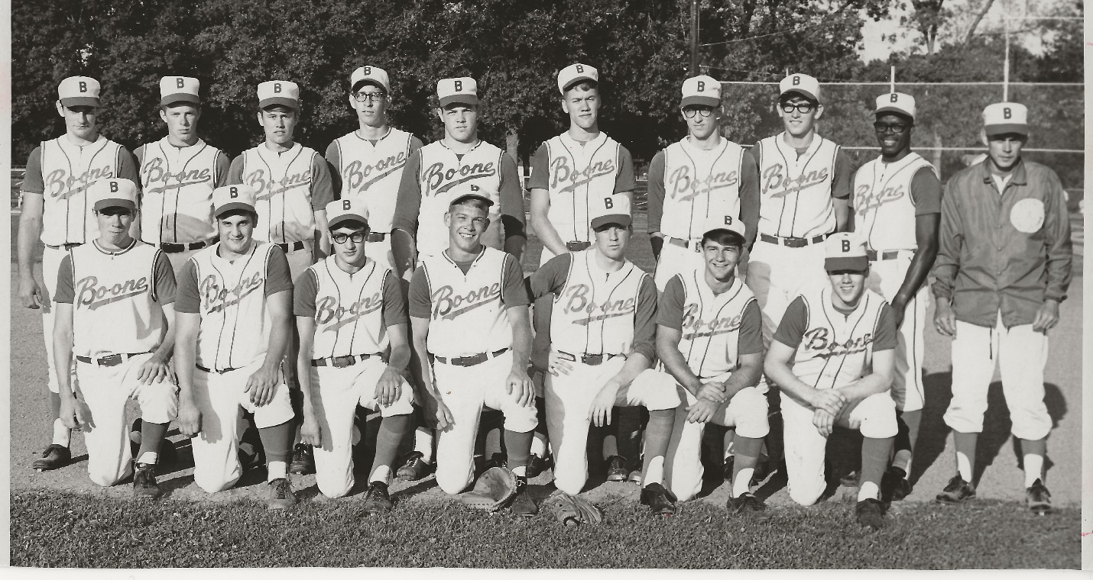
Football: 1968 was another special year for Boone football. The offense was led by quarterback Roger Martin and powered by the rushing attack of Paul McIntyre and Ed Frazier. The two ran behind a solid line: Chuck Jipp (186)-Left End, Steve Paris (200)-Left Tackle, Ray Greco (160)-Left Guard, Gary Sutton (174)-Center, Brad Clark (175)-Right Guard, Jim Niemants (192) -Right Tackle, Scott Lilly (157)-Right End. For those days, this was a big line. After an initial 32-32 tie with Ames, the Toreadors won 7 straight outscoring their opponents 241-82. They ended the year ranked 12th in the state with a record of 7-0-1. Niemants, Greco, Sutton, McIntyre, Jipp, Paris and Martin were all on the first team all-Conference. Paris was named 3rd team all-state and McIntyre to the 5th team. McIntyre ran for 1,300 yards on 215 carries.

1969: Wrestling: Paul McIntyre finished third in the state.
Boys’ Golf: The Toreadors qualified for the state tournament for the second year in a row, finishing fourth. Five individuals played in each varsity meet with the top four scores counting toward the team score. Juniors Brad Post and Charles Updegraff played in the #1 and #2 slots, sophomore Doug Miller was #3, and sophomore Jeff Rees typically #4. Sophomores Jim Curell, Jeff Saggau, and Bob Sapp played off for the fifth slot before each meet. Each of the three played in six varsity meets with Jeff playing in the Sectional, Jim in the District, and Bob in the State.

1970: Girls’ Basketball: Jim Grider took over as head coach. The season looked promising with the entire forward court returning. Carole Grabau was a senior who had averaged 25.9 points a game the year before. Janie Huddleston returned as a junior and sophomore Marsha Lilly completed the offensive attack. It became apparent that Marsha was a special talent. The team finished 15-8 and one game shy of the state tournament. Marsha led the way with a 27.3 points per game average.
Boys’ Golf: The Toreadors win the state championship. Utilizing the same seven players and the same rotation as the year before, Boone was 9-0 in dual meets, then won the CIC, the Sectional and District meets leading up to the state championship. Brad Post was the state individual champion shooting a 71 on the tough Iowa State Veenker course. Once again, Brad Post, Charles Updegraff, Doug Miller and Jeff Rees played in the top four slots. The other three played off before each meet with Bob Sapp playing in the Sectional, Jim Curell in the District and Jeff Saggau in the State.
Baseball: After a disappointing 1969 season (17-13), only one senior came out for the baseball team. So, the positions were filled by juniors with a couple of sophomores rotating in when needed. The inexperienced team started slowly losing their first four games. But they gained momentum as the season progressed finishing 8-4 in the CIC (second to Urbandale). In addition, they won their sectional tourney and beat Indianola for the district championship and a berth into the state tournament. That victory over Indianola was notable as they beat one of the best pitchers in the state, Tom Steen, who had been undefeated to that point. Boone won 12 of 13 games during that stretch. The team fell to Cedar Rapids Jefferson (4-2) in the first round of the state held at the Carroll Stadium. They ended the season with a record of 20-11.
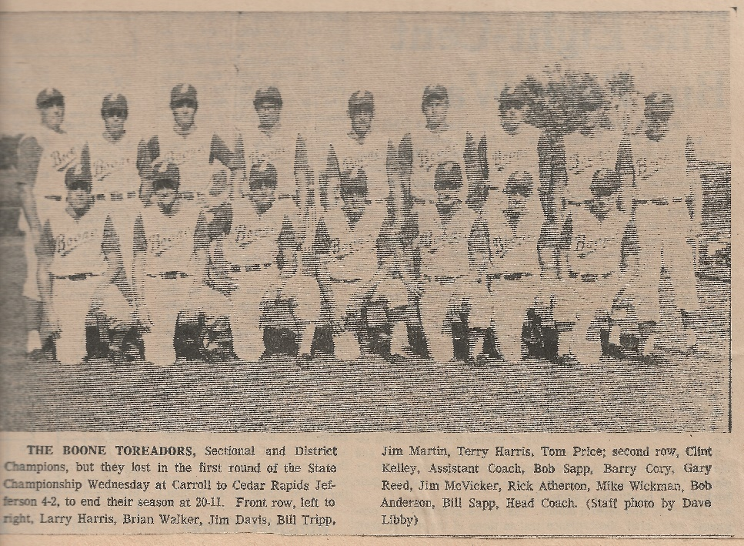

1971: Girls’ Basketball: Led by juniors Marsha Lilly in the forward court and Judy Peterson in the guard court, the Toreadorettes (as they were known then) ended the season 17-6 just one game shy of the state tournament berth again. Marsha averaged 43.2 points per game and became the leading scorer in Boone High School history. Both Marsha and Judy were named to the all-district team.
Wrestling: Jeff Saggau finished second in the state.
Boys’ Golf: Returning five of the top seven golfers from the state championship team, the Toreadors once again qualified for the state meet (fourth year in a row). Along the way, the team was 8-2 in dual meets, winning both the CIC and District titles. However, they struggled on a windy May day in the State meet finishing 12th.

Baseball: With everyone returning except for one from the 1970 team, the Toreadors had high hopes for their 1971 season. Starting 10-0, the team seemed like they were on their way. But a lackluster performance in the Burlington Invitational (two losses) led to a five-game losing skid. But all those losses were close and to solid teams (Burlington, Decorah, Indianola, Fort Dodge, and Ames). The team rallied, winning 10 of their last 12 regular season games. A big win at Indianola beating their ace again, Tom Steen, 4-1, led to the CIC title with a 13-1 conference record. The Toreadors easily won their first five games of the tournament. In the District finals, they had to face a tough Carroll Kuemper team touted as the best squad in western Iowa. They threw their top pitcher, left hander, Bill Henkenius. Boone won 2-1 with Barry Cory executing a perfect suicide squeeze bunt for the winning run. Unfortunately, the Toreadors played maybe their worst game of the season getting beat by Iowa Falls in the first round of the state tournament, 5-1. The team ended the season with a 26-8 record. Larry Harris led the team in hitting with a .449 average followed by Jim Martin at .337. Tom Price was superb on the mound registering a 13-3 record and a 1.40 ERA.
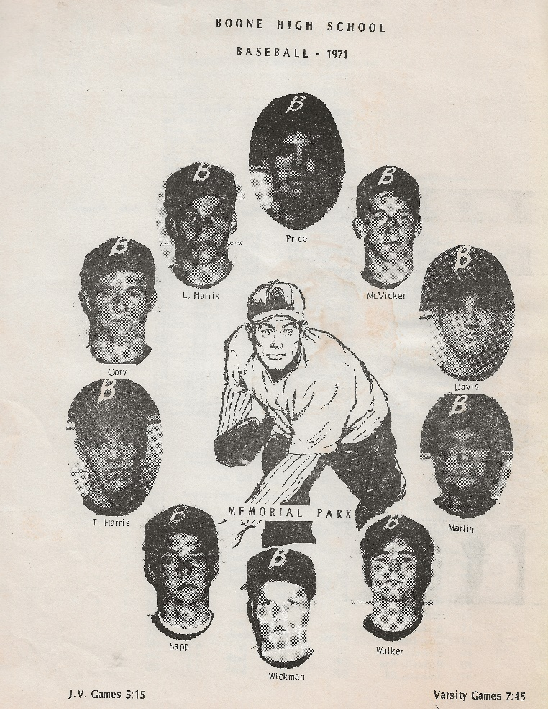
Front of 1971 Baseball Program

1972: Girls’ Basketball: With seniors Marsha Lilly and Judy Peterson leading the way, the team finished with a sparkling 19-3 record. Once again, they were one game short of a state tournament berth. Due to a quirky play-back rule, Ogden qualified for state even though Boone had just beat them in the first round of the district, as well as by 20 points earlier in the year. Marsha averaged 44.8 points per game including a record 73-point performance against Central Dallas. She ended her career with 2,775 points, a record that still stands.
Baseball: This was a tale of two seasons. With all the graduations, this Toreador team was starting from scratch. During the regular season, the team was very inconsistent. There were moments of brilliance but usually overshadowed by errors and mental mistakes. They finished the regular season 9-14. But then they got on a roll winning six in a row to reach the state tournament for the third straight year. They won their first-round game at state but got beat in the second. They came back to win the consolation game finishing 3rd in the state. Their final record was 17-15.

Here is what this decade produced:

Boys Basketball: The last state tournament appearance for the Toreadors. Roger Dutton was named to the first team all-state. He is now a member of the Iowa High School Basketball Hall of Fame.
Girls’ Basketball: For the three-year period from 1969-70 through 1971-72, the team was 51-17. Marsha Lilly broke the all-time scoring record by more than 1,300 points. On a side note, Judy Peterson, the all-district guard is the mother of Nick Collison, who became an all-American at Kansas and NBA great.
Swimming: Over this 10-year span, the swimming team, led by Coach Ed Morgan, set new Boone High records in every event.
Boys Golf: The team qualified for the state tournament from 1968 through 1971. During those four years, the team was 32-5 in dual meets, won 3 CIC titles, 2 Urbandale Invitational titles, 2 Sectional and 2 District Championships along with one State title. The average nine-hole individual score for each year was as follows: 40.31 in 1968, 39.49 in ’69, 38.06 in ’70 and 38.71 in ’71. Of the seven individuals who saw varsity action in 1969 and 1970, six received Division I scholarships…. Brad Post and Charles Updegraff to the University of Iowa…. after 2 years at Boone JC, Doug Miller played at Iowa State…. Jeff Rees at Memphis State…. Bob Sapp, a partial golf scholarship at Drake….. and Jeff Saggau wrestled at the University of Wisconsin. The 7th member, Jim Curell, led the Boone Junior College golf team to the national tournament in Florida and then went on to be one of the top amateur players in Iowa, winning the Iowa Golf Association Player of the Year award in 1979.
Baseball: Under the direction of head coach, Bill Sapp, for 1963 through 1972, the Toreadors were 206-72 (74.1%). They won 5 CIC titles and finished second 4 times. During that time, Boone won 10 Sectional tourneys, 6 District titles, had 5 state tournament appearances that included 2 state titles and a 3rd place finish. The most prolific years were from 1965 through 1968 when the teams were 95-14 with 4 conference titles and 2 state championships.
Football: For the decade of the 60’s (1960-69), the Toreadors were 51-22-6. That included two undefeated teams and three one-loss seasons along with the mythical state championship in 1964. Merle Harris coached all those teams. He retired after the 1971 season. After Boone was 1-6 in 1974 and 0-7 in 1975, Merle returned to lead the Toreadors once again. His 1976 team went 7-1, winning another conference title. Merle suffered a heart attack after the last game and retired once again.

Other

In addition to the achievements mentioned above, there were several other outstanding individual performances during this decade. In 1963, Roger Dutton set Boone High records in three different track events… the long jump (20’7”), high jump (5’8 ½”) and pole vault (12’0”). John Hendricks was among the best in the state for both the discus and shot put. In 1971, Jon Sunstrom won the 3A state title in the fall mile run competition. Marsha Lilly set the Boone High single game scoring record of 63 points as a junior and then broke it the next year with a 73-point performance as a senior. A number of these athletes went on to success at higher levels. Roger Dutton played AAA baseball with the Yankees. John Hendricks started for the Iowa Hawkeyes football team. Mike Harris starred at Coe College. Kelly McMullan was named as an NAIA All-American for baseball. Jack Mustapha was drafted by the Cardinals before hurting his back in a helicopter crash in Vietnam. Several baseball players had college success…Steve Crandell at ISU, Dick Sapp and Steve Fontanini at Drake, Joe Fontanini at Buena Vista. There were many others…..it was quite a decade!

Conclusion

In summary, if we assume that the 1964 football team was #1 in the state, the decade yielded eleven state tournament appearances, four state team championships, two individual state champions, eleven conference championships and numerous all conference athletes. Let’s not forget that it produced the leading scorer in Boone girls’ basketball history. Why? What made this period so productive? It would be easy to say that it simply was a time when we had great athletes. I believe that every generation has the potential to be great. But talent must be nurtured, then freed to flourish before it is focused to achieve. All these elements were present during this decade.

First there was great community support. Parents were very supportive and active. They petitioned the school to reinstate baseball and add wrestling. Parents organized the Little League and Babe Ruth programs. They were youth coaches and volunteers who built and maintained the diamonds or worked in the concession stands. The local businesses sponsored youth baseball teams, hired the young athletes with flexible schedules and advertised in the Boone News Republican in support of the high school teams. The Boone News Republican dedicated a full page of each paper (six days a week) to sports. Mr. Mo Kelley made sure that this page was dominated by local sports stories including his Kelley’s Korner (still an active internet blog). Big articles were written with pictures and box scores of the high school games. In addition, every Little League, Babe Ruth and Gray-Y game was covered with highlights of who got hits, the winning or losing pitcher, or who scored the points. It always included an update of the team standings. This was all done with an attitude of support and a focus on teaching the fundamentals of the game.
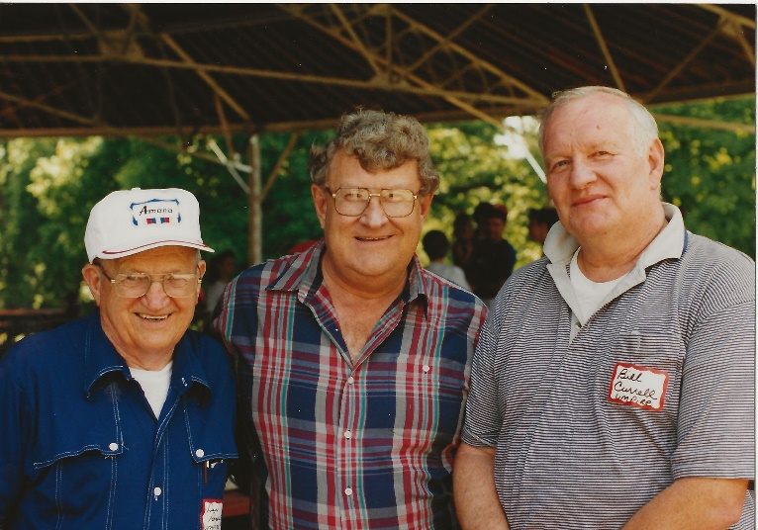
Mo Kelley (center) with long time baseball umpires Dan Rogers (left) and Bill Curell.
Secondly, Boone was blessed with outstanding high school coaches. Both Merle Harris and Bill Sapp are in the Hall of Fame as coaches of their respective sports. Merle and Bill were made from the same cloth. Both were outstanding athletes. Merle was a star in Webster City. Known as “Cotton” for the color of his hair, he excelled in football, basketball, track, and baseball. After high school, he played basketball for one year at Webster City JC leading the team to the national tournament. Then he accepted a football and track scholarship to Iowa State. Bill starred in football, basketball, and baseball at Nevada. He went on to letter in both basketball and baseball at Drake. Both were fierce competitors who knew how to win. Their coaching philosophy was simple…. teach the fundamentals and expect nothing less than 100% from each player. They were men of few words who ran their programs with great integrity. They had the ability to get the most out of the talent given to them and place each person in the correct position to garner team success. They were driven by a love of the game and a love of kids. They supported each other’s program. Merle and Bill encouraged players to participate in other sports. They believed it made them better athletes. They respected and supported the other coaches during their respective season.
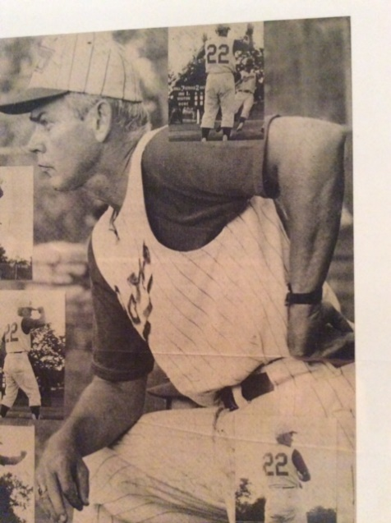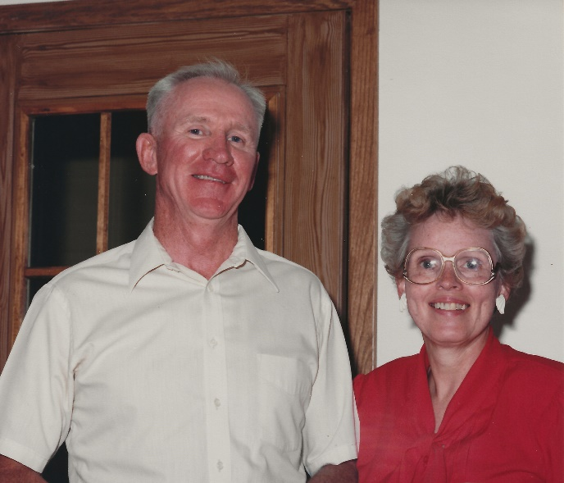
Bill Sapp (left) ; Merle and Litta Harris (right)

In addition, there was an outstanding supporting cast of coaches as assistants and [Grab your reader’s attention with a great quote from the document or use this space to emphasize a key point. To place this text box anywhere on the page, just drag it.]
Junior High coaches. They included individuals like Hal Lyness, Larry Blaker, Dick Criner, Ralph Carroll, Clint Kelley, Gary Meyers and others. On a personal note, if my dad (Bill Sapp) was here, he would tell you that his Christian faith was the basis for his success. It gave him the proper perspective…. sports are a microcosm of life. Many life lessons are learned on the fields of sport. He was on a mission to build the character in the young men that he coached. I know the other coaches felt the same.

All of this contributed to a momentum of success. As a young kid, you looked up to the high school athletes and aspired to compete as they did. There was an expectation of success…. we expected to win. And for those years, there was a lot of winning.
Honor Roll by Sport (This list has some holes (especially 1971 and 1972 for Baseball) …I would welcome additions):

Boys Basketball Honor Roll (1963-1972)
Year | Individual | Honor
1963 | Roger Dutton | 1st Team All-state, 1st Team All CIC
 | Mike Loehrer | 2nd Team All CIC
 | Dick Musser | 3rd Team All CIC
1964 | Mike Loehrer | 1st Team All CIC
1965 | Mike Harris | 3rd Team All CIC
1966 | Brian Larson | 2nd Team All CIC
 | Mike Harris | 2nd Team All CIC
1967 | Topper Lyness | 1st Team All CIC
 | Kelly McMullan | 2nd Team All CIC
1968 | Joel Teagarden | 1st Team All CIC
 | Gary Eckley | 2nd Team All CIC
 | Roger Martin | 3rd Team All CIC
1969 | Roger Martin | 1st Team All CIC
1970 | Tom Myers | 1st Team All CIC
 | Gary Hudson | 2nd Team All CIC
1971 | Gary Hudson | 1st Team All CIC
1972 | Ron Sundall | All CIC

Girls Basketball Honor Roll
1962 | Jackie Parrish | 1st Team All-State
1963 | Jackie Parrish | 1st Team All-State
1964 and 1965 | Teri Carlson | All District
1971 | Marsha Lilly | All District
 | Judy Collison | All District
1972 | Marsha Lilly | All District
 | Judy Collison | All District

Football Honor Roll (1962-1970)
1962 | Roger Dutton | 1st Team All CIC; 5th Team All-State
 | Toby Anderson | 1st Team All CIC
 | Mike Loehrer | 2nd Team All CIC
 | John Hendricks | 2nd Team All CIC
1963 | Jude Rolfes | 1st Team All CIC
 | Dick Musser | 1st Team All CIC
 | John Hendricks | 1st Team All CIC; 1st Team All-State
 | Toby Anderson | 1st Team All CIC; 3rd Team All-State
 | Brett Downey | 2nd Team All CIC
 | Mike Loehrer | 2nd Team All CIC
 | Sandy Mahood | 3rd Team All CIC
1964 | Steve Bancroft | 1st Team All CIC
 | John Newland | 1st Team All CIC
 | Marty Rinehart | 1st Team All CIC; Named one of state’s top 15 running backs
 | Sid Ericson | 1st Team All CIC; 1st Team All-State
 | Don Riker | 1st Team All CIC; 4th Team All-State
 | Ted Hora | 2nd Team All CIC
 | Mike Harris | 2nd Team All CIC
1965 | Mike Harris | 1st Team All CIC; 1st Team All-State
 | Steve Bennett | 1st Team All CIC
 | Bruce Richeson | 2nd Team All CIC
 | Steve Crandell | 2nd Team All CIC
 | Kelly McMullan | 3rd Team All CIC
 | John Winters | 3rd Team All CIC
1966 | Kelly McMullan | 1st Team All CIC
 | Rick Neely | 2nd Team All CIC
 | Topper Lyness | 3rd Team All CIC
 | Don Wilhite | 3rd Team All CIC
1967 | Steve Paris | 1st Team All CIC
 | Jim Jewett | 2nd Team All CIC
 | Dick Sapp | 3rd Team All CIC
1968 | Roger Martin | 1st Team All CIC
 | Jim Niemants | 1st Team All CIC
 | Ray Greco | 1st Team All CIC
 | Paul McIntyre | 1st Team All CIC; 5th Team All-State
 | Chuck Jipp | 1st Team All CIC
 | Steve Paris | 1st Team All CIC; 3rd Team All-State
 | Gary Sutton | 1st Team All CIC
1969 | Paul McIntyre | 1st Team All CIC
 | Ed Frazier | 1st Team All CIC
 | Brian Walker | Honorable Mention CIC
 | Bill Wallace | Honorable Mention CIC
 | Stan Sutton | Honorable Mention CIC
 | Mike Byriel | Honorable Mention CIC
1970 | Spike Davis | 1st Team All CIC
 | Jim McVicker | 1st Team All CIC
 | Larry Harris | 1st Team All CIC

Baseball Honor Roll (1963-1972)
1963 | Don Riker | 1st Team All CIC
 | Mike Loehrer | 1st Team All CIC
 | Jack Mustapha | 1st Team All CIC
 | Dick Musser | 2nd Team All CIC
 | Roger Dutton | 2nd Team All CIC
 | Pat Ahlstrom | 2nd Team All CIC
1964 | Don Riker | 1st Team All CIC
 | Mike Loehrer | 1st Team All CIC
 | Jack Mustapha | 1st Team All CIC
 | Dick Musser | 2nd Team All CIC
 | Bruce Geerdes | 2nd Team All CIC
 | Marty Rinehart | 2nd Team All CIC
1965 | Jack Mustapha | 1st Team All CIC; Iowa Baseball Hall of Fame
 | Bruce Geerdes | 1st Team All CIC
 | Mike Harris | 1st Team All CIC
 | Steve Crandell | 1st Team All CIC
 | Don Riker | 2nd Team All CIC
 | Marty Rinehart | 2nd Team All CIC
 | Bob Hopkins | Honorable Mention All CIC
 | Rick Davis | Honorable Mention All CIC
 | Clyde Hovick | Honorable Mention All CIC
1966 | Mike Harris | 1st Team All CIC
 | Bob Hopkins | 1st Team All CIC
 | Topper Lyness | 1st Team All CIC
 | Kelly McMullan | 1st Team All CIC
 | Steve Crandell | 1st Team All CIC
 | Tom Peterson | 2nd Team All CIC
1967 | Joe Fontanini | 1st Team All CIC
 | Topper Lyness | 1st Team All CIC
 | Dick Sapp | 1st Team All CIC
 | Kelly McMullan | 1st Team All CIC
 | Jack Teagarden | 1st Team All CIC
1968 | Ron Nunn | 1st Team All CIC
 | Joe Fontanini | 1st Team All CIC; 2nd Team All State
 | Denny DeLance | 1st Team All CIC; 3rd Team All State
 | Joel Teagarden | 1st Team All CIC
 | Mark Whitmer | 2nd Team All CIC
 | Gary Eckley | 2nd Team All CIC
 | Ron Neely | Honorable Mention
 | Marty Dannatt | Honorable Mention
 | Dick Sapp | Honorable Mention
1969 | Steve Fontanini | 1st Team All CIC
1970 | Terry Harris | 1st Team All CIC
 | Brian Walker | 1st Team All CIC
 | Bob Sapp | 2nd Team All CIC
 | Jim Martin | 2nd Team All CIC
 | Tom Price | 2nd Team All CIC; 4th Team All State
 | Larry Harris | Honorable Mention All CIC
 | Barry Cory | Honorable Mention All CIC
 | Spike Davis | Honorable Mention All CIC
 | Rick Atherton | Honorable Mention All CIC
1971 | Tom Price | 2nd Team All District
 | All CIC Honors not published
1972 | All CIC Honors not published

